Name: __________________________ Date: ______________

Class: _____________

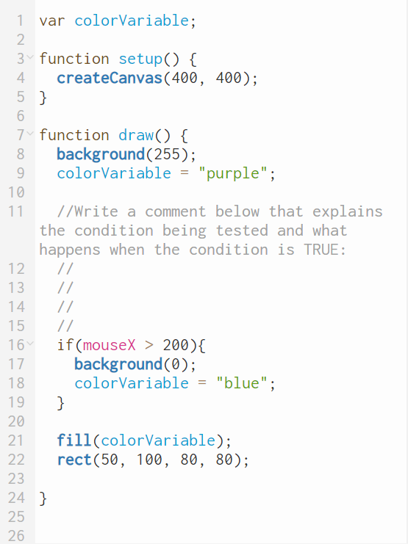

Name: __________________________ Date: ______________

Class: _____________

